# Business Requirements Document (BRD)

## Feature Name: Restrict Self-Approval and Approver List Refinement

## 1. Objective

The objective of this feature is to ensure compliance with organizational approval policies and enhance the integrity of the approval process by eliminating the possibility of users approving their own timesheets or expense reports. This will be achieved by:

1. Excluding self-submitted records from all approval-related interfaces, such as approval gadgets and approval lists.  
  
2. Preventing users from appearing in the approver list when submitting expense reports if the override approval rule is enabled.  
  
3. Using the original logged-in user's identity for all self-approval validation checks, even in cases of role-switching or impersonation.

These enhancements promote fairness, transparency, and adherence to organizational standards.

## 2. Problem Statement

The current system allows users to approve their own timesheets and expense reports. Additionally, when submitting expense reports with the override approval rule enabled, the system includes the submitter in the list of approvers. These gaps introduce potential conflicts of interest and compromise the transparency of the approval workflow. To maintain compliance, it is essential to restrict self-approval and refine the approver list to exclude the submitter.

## 3. Proposed Solution

To address these issues, the following enhancements will be implemented:

1. Exclude self-submitted records from all sections of approval gadgets (Unsubmitted, Pending Approval, Rejected, Approved) and the approval list UI.  
2. Prevent self-approval attempts by validating the original logged-in user's identity against the submitter ID, even in role-switching scenarios.  
3. Exclude the submitter from the list of approvers when submitting expense reports if the override approval rule is enabled.  
4. Log all self-approval attempts for auditing purposes.

## 4. Scope

### In-Scope:

- Exclude self-submitted records from all sections of approval gadgets.  
- Prevent self-submitted records from appearing in the approval list UI.  
- Exclude the logged-in user from the approver list if the override approval rule is enabled.  
- Validate against the original logged-in user's identity to prevent self-approval.  
- Log all self-approval attempts.

### Out-of-Scope:

- Changes to submission workflows for timesheets or expense reports.  
- Enhancements to analytics or reporting modules.

## 5. Functional Requirements

1. Approval Gadget Updates:  
 - Exclude self-submitted records from all four sections: Unsubmitted, Pending Approval, Rejected, Approved.  
2. Approval List UI Behavior:  
 - Self-submitted records will not appear in the approval list UI.  
3. Validation for Self-Approval Attempts:  
 - Use the original logged-in user's identity for validation, even if roles are switched.  
 - Prevent users from approving their own submissions.  
 - Display the error message: 'You cannot approve your own timesheet or expense report.'  
4. Exclude Submitter from Approver List:  
 - When the override approval rule is enabled, exclude the submitter from the list of approvers displayed during expense report submission.  
5. Logging and Auditing:  
 - Log all self-approval attempts, including user ID, timestamp, record type, and record ID.

## 6. Non-Functional Requirements

1. Performance: Ensure exclusions and validations do not impact the performance of approval gadgets, approval lists, or dropdowns.  
2. Scalability: Support efficient handling of exclusions and validations for large datasets and multiple concurrent users.  
3. Reliability: Ensure all restrictions and validations work consistently across modules, roles, and impersonation scenarios.

## 7. Risks and Mitigations

1. Risk: Misconfiguration of Role-Switching Mechanism  
 - Mitigation: Thorough testing of role-switching scenarios.  
2. Risk: User Frustration with Excluded Records  
 - Mitigation: Provide clear communication and documentation about the changes.  
3. Risk: Approval Delays  
 - Mitigation: Encourage proper delegation of approval responsibilities.

## 8. UI/UX Changes

1. Approval Gadgets:  
 - Exclude self-submitted records from all four sections.  
 - Adjust counts to reflect only eligible records.

Employee’s own timesheet / expense reports will be excluded from both of dashboards below.  
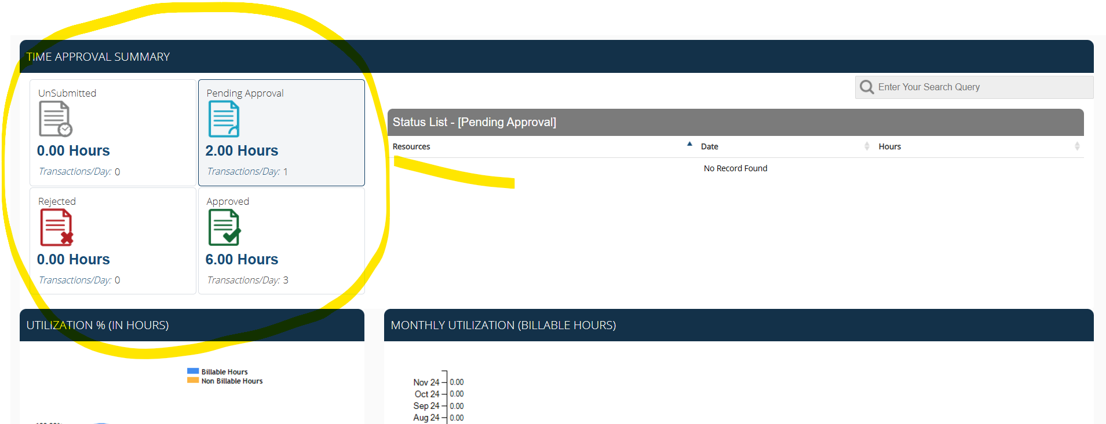

2. Approval List UI:  
 - Ensure that self-submitted records are filtered out and system doesn’t display logged-in resource in Employee’s dropdown for selection in both Expense report and Timesheet UI.

Incase of timesheet approval, if user has selected approval by Level2, system shouldn’t load any timesheet record which belongs to logged-In user.

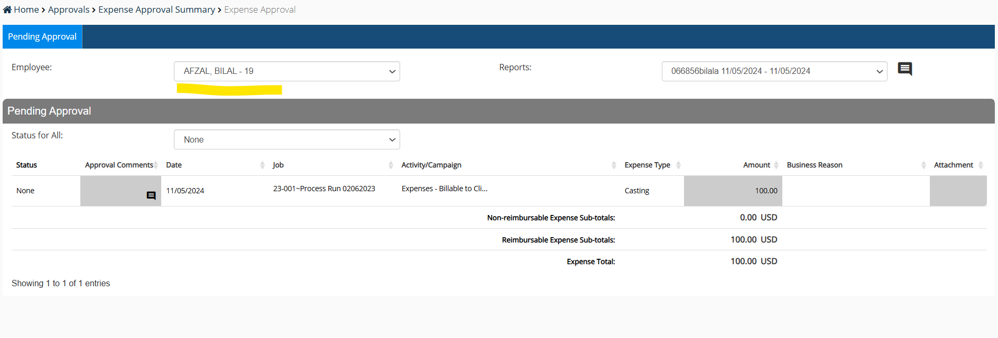

3. Approver List in Expense Report Submission:  
 - When the override approval rule is enabled, exclude the submitter from the list of approvers.  
  
  
4. Error Messaging:  
  
we need to add an additional check in database to make sure user is not able to approve his own timesheet / expense report , this is because FE can be compromised that’s why we need to have check in the backend as well.  
  
 - Display the error message for self-approval attempts: 'You cannot approve your own timesheet or expense report.'

## 9. Assumptions

1. Users are uniquely identified in the system, and their identity is consistently tracked across role-switching scenarios.  
2. The system already supports dynamic filtering for approver lists based on business rules.  
3. The override approval rule is enabled only when required, and the logic applies only in those cases.

## 10. Success Criteria

1. Self-submitted records are excluded from all sections of approval gadgets and approval lists.  
2. The logged-in user is excluded from the approver list during expense report submission if the override rule is enabled.  
3. Users cannot approve their own submissions under any circumstances.  
4. All self-approval attempts are logged for audit purposes.  
5. System performance remains unaffected by the new validations and restrictions.